Name: _____________________________ Right Triangle Trigonometry
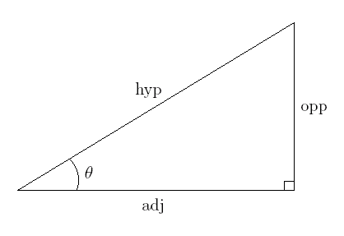
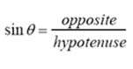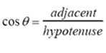
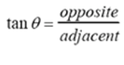

In each diagram, identify the following:

1.
- Sin $Ѳ$ =

- Cos $Ѳ$ =

- Tan $Ѳ$ =

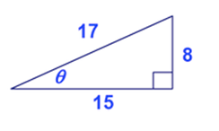

2.
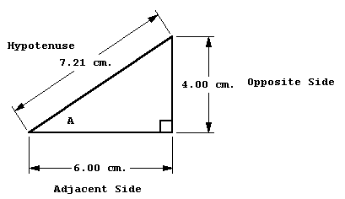
- Sin $A$ =

- Cos $A$ =

- Tan $A$ =

3.
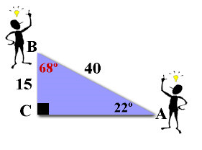
Do you notice anything about the above answers?
- Sin $B$ =

- Cos $B$ =

- Tan $B$ =

- Sin $A$ =

- Cos $A$ =

- Tan $A$ =

4.
- Sin $T$ =

- Cos $T$ =

- Tan $T$ =

- Sin $C$ =

- Cos $C$ =

- Tan $C$ =

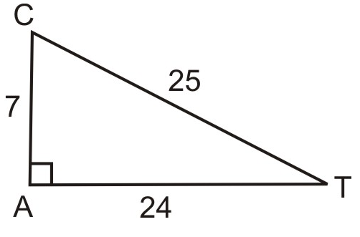
Do you notice anything about the above answers?

5.
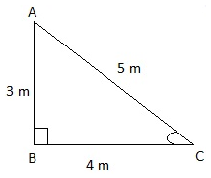 Do you notice anything about the above answers?
- Sin $A$ =

- Cos $A$ =

- Tan $A$ =

- Sin $C$ =

- Cos $C$ =

- Tan $C$ =

6.
- Sin $T$ =

- Cos $T$ =

- Tan $T$ =

- Sin $C$ =

- Cos $C$ =

- Tan $C$ =

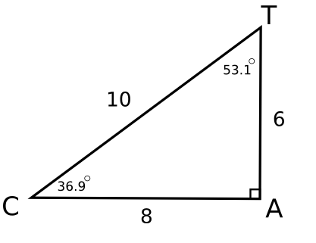 Do you notice anything about the above answers?
7. If Cos D = $\frac{7}{18}$ , what is the Sin of G?
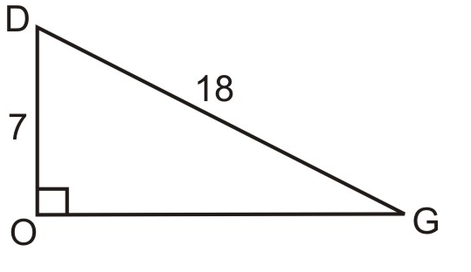
8. If Cos $Ѳ$ = $\frac{9}{13}$ , what is the Sin of the missing angle?
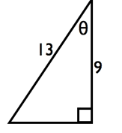

9. If Sin $Ѳ$ = $\frac{6}{11}$, what is the Cos of the missing angle?
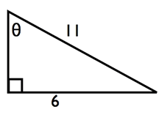
10.

11. In right triangle DOG with the right angle at O, sin D = 3x - .7 and cos G = 8x - 23. Determine and state the value of x. Explain your answer.

12. In right triangle HAT with the right angle at H, sin A = x + .2 and cos T = 7x - .1. Determine and state the value of x. Explain your answer.

13. In right triangle TOE with the right angle at O, sin T = 7x - .6 and cos E = 4x + 9 . Determine and state the value of x. Explain your answer.

14. In right triangle SAM with the right angle at A, sin S = 5x - .7 and cos M = 9x - .46 . Determine and state the value of x. Explain your answer.

